28.17: The only place where the magnetic fields of the two wires are in opposite directions is between the wires, in the plane of the wires.
Consider a point a distance x from the wire carrying  = 75.0 A. 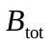 will be zero where 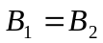.
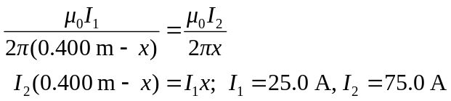

x = 0.300 m; 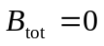 along a line 0.300 m from the wire carrying 75.0 A amd 0.100 m from the wire carrying current 25.0 A.
b) Let the wire with 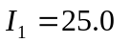A be 0.400 m above the wire with = 75.0 A. The magnetic fields of the two wires are in opposite directions in the plane of the wires and at points above both wires or below both wires. But to have must be closer to wire #1 since 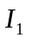< , so can have only at points above both wires.
Consider a point a distance x from the wire carrying 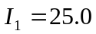 A. will be zero where 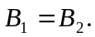

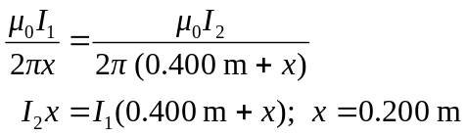

along a line 0.200 m from the wire carrying 25.0 A and 0.600 m from the wire carrying current 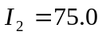 A.

